**Week 2: Advanced SQL,**

**SQL Exercises: Advanced SQL Concepts**

**Exercise 1: RANKING AND WINDOW FUNCTIONS**

**QUERY:**

WITH Ranked AS (

SELECT

ProductID,

ProductName,

Category,

Price,

ROW_NUMBER() OVER (PARTITION BY Category ORDER BY Price DESC) AS RowNum,

RANK() OVER (PARTITION BY Category ORDER BY Price DESC) AS RankNum,

DENSE_RANK() OVER (PARTITION BY Category ORDER BY Price DESC) AS DenseRankNum

from

Products

)

select * from Ranked where RowNum <= 3;

**Output:**

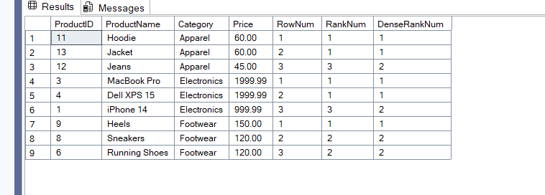

**SQL Exercise: Stored Procedure**

**Exercise 1: Create a Stored Procedure**

**1.Define the stored procedure with a parameter for DepartmentID.**

Create PROCEDURE sp_GetEmployeesByDepartment

@DepartmentID INT

AS

BEGIN

select * from Employees

where DepartmentID = @DepartmentID;

END;

**2. Select employee based on DepartmentID**

SELECT * FROM Employees WHERE DepartmentID = 3;

**Output:**

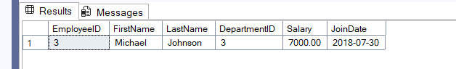

**3. Stored procedure named ‘sp_InsertEmployee’**

EXEC sp_InsertEmployee

@EmployeeID = 8,

@FirstName = 'Kaushik',

@LastName = 'Arun',

@DepartmentID = 1,

@Salary = 78000.00,

@JoinDate = '2026-06-08';

**Output:**

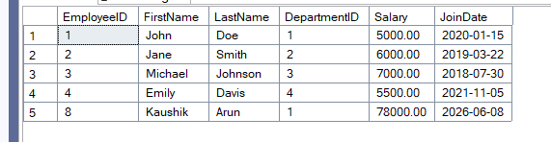

**SQL Exercises: Functions**

**Exercise 7: Return data from Scalar function**

**1.Execute the `fn_CalculateAnnualSalary` function for an employee with `EmployeeID = 1`.**

create FUNCTION dbo.fn_CalculateAnnualSalary (@EmpID INT)

returns DECIMAL(12,2)

AS

BEGIN

DECLARE @Annual DECIMAL(12,2);

select @Annual = Salary * 12

from Employees where EmployeeID = @EmpID;

RETURN @Annual;

END;

GO

SELECT dbo.fn_CalculateAnnualSalary(1) AS AnnualSalary;

**Output:**

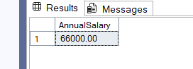

**2. Verify the result**

SELECT e.EmployeeID,

e.FirstName,

e.LastName,

d.DepartmentName,

e.Salary AS MonthlySalary,

dbo.fn_CalculateAnnualSalary(e.EmployeeID) AS AnnualSalary

FROM Employees e

JOIN Departments d ON d.DepartmentID = e.DepartmentID

WHERE e.EmployeeID = 1;

**Output:**

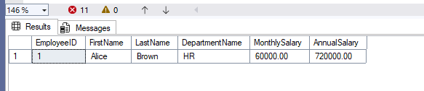

**SQL Exercise: Stored Procedure**

**Exercise 5: Return Data from a Stored Procedure**

**1.Stored Procedure with DepartmentdID**

create PROCEDURE sp_GetEmployeeCountByDepartment

@DepartmentID INT

AS

BEGIN

select COUNT(*) AS EmployeeCount from Employees

where DepartmentID = @DepartmentID;

END;

**2.Query for count the number of employees in the department**

EXEC sp_GetEmployeeCountByDepartment @DepartmentID = 1;

**Output:**

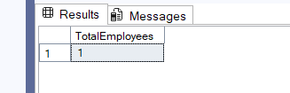

**SQL Exercise: Stored Procedure**

**Exercise 4: Execute a stored procedure**

**1.To Execute the stored procedure**

EXEC sp_GetEmployeesByDepartment @DepartmentID = 4;

**Output:**

